

Multidimensional Visualisation of Healthcare Utilisation and Outcomes among Humanitarian Entrants and Other Permanent Migrants in Australia

Table of Contents
1. Introduction 3
2. Dataset and Data Preparation 3
3. Visualisation Methods, Results and Findings 4
3.1 Geographic Hospitalisation Rates 4
3.2 Hospitalisation Rates over Time 5
3.3 Lower-Urgency Emergency Department Presentations 6
3.4 Mode of Arrival at Emergency Departments 7
3.5 Potentially Preventable Hospitalisations 8
3.6 Injury Hospitalisation Composition 9
4. Dashboard Interaction, Large Data and Critical Evaluation 10
5. Conclusion 11
Reference List 12

1. Introduction
Data Visualisation has made it easy for understanding the complex quantitative information by converting them into graphical forms. Highly beneficial for multifaceted datasets, where multiple variables must be interpretated parallelly. For example, the healthcare dataset used in this report has different categories like population, geographical area, time-period and type of health service. With proper visual representation it enables a huge amount of information to be evaluated more effectively. The argument between Cleveland and McGill (1984) regarding the impact of statistical visuals is determined by the accuracy of the viewers who can understand diverse visuals, while Shneiderman and Heer (2012) emphasised the necessity of interaction in facilitating users to explore and fine-tune their visual analysis.
The report is based around the analysis of healthcare service consumption among humanitarian entrants and other permanent migrants in Australia utilising the data from Australian Institute of Health and Welfare (AIHW). The AIHW report partly include the data of housing assistance services by refugees and humanitarian entrants. Information such as hospitalisations and emergency department (ED) from 2016-17 to 2020-21. The AIHW report demonstrates that humanitarian entrants where more likely to be hospitalised or visit an ED when compared to other permanent migrants (AIHW 2024).
The aim of this report is to analysis and evaluate the differences in healthcare consumption according to financial year, migrant cohort, state or territory and other healthcare consequences. Six supplementary visuals were created using Tableau: line chart, heatmap, 100% stacked bar chat, treemaps, geographic map and dot plot. The combined interactive dashboard was created using these visuals for understanding and detailed exploration of the data.

2. Dataset and Data Preparation
A total of five tables were selected from the datasets. Hospitalisation and ED presentation measures from Table S4.1; lower-urgency ED care from Table S4.2; arrival mode data from Table S4.3; possibly preventable hospitalisation from Table S4.4; Hospitalisation based on categorical injury from Table S4.6. Every table contain multiple datasets particularly financial year, cohort and state or territory. Quantitively measure such as rates, counts and proportions are also included.
All the tables were imported as independent data sources over Tableau. For identifying suitable heading and formatting elements data interpreter was used. For state-level comparison “Total” record was excluded but retained for national level analysis. In several visualisations rates per 1000 people were used to raw counts as the cohort population differs in size allowing meaningful comparison rather simply reflecting a huge population.
The analysis was within the limitation of source data where Western Australian and Northern Territory were not part of Hospitalisation and ED information in AIHW analysis. Rather than representing all non-emergency presentations, lower-urgency ED care specifically identified triage category, arrival mode and discharge results AIHW 2024). Subsequently, the dashboard comprises a descriptive pattern among the supplied body of data rather than a complete measure of healthcare utilisation.

3. Visualisation Methods, Results and Findings

3.1 Geographic Hospitalisation Rates
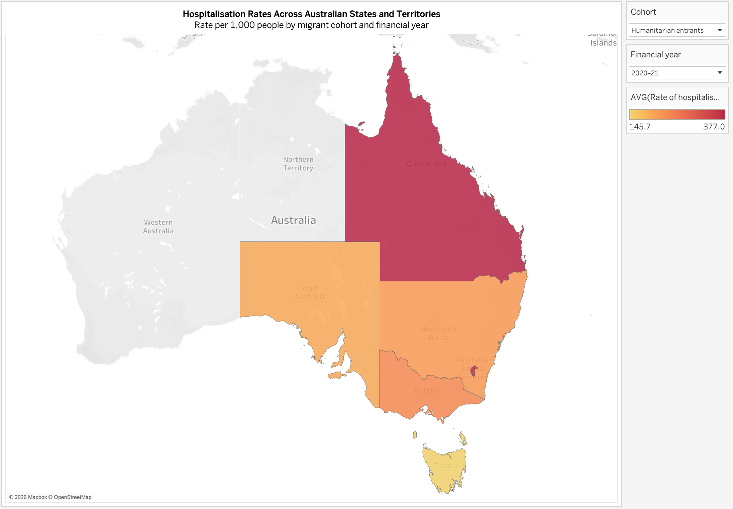
Hospitalisation Rate Across Australian States & Territories Rate per 1000 people by migrant cohort and financial year
The geographic map is the first visualisation of this analysis, where the hospitalisation rate per 1000 people is shown, with an interactive selection for migrant cohort and financial year. The fundamental aspect of the data was clearly shown using the geographical visualisation and the interactive maps allow the user to study different locations (Roth 2013).
Queensland recorded the highest hospitalisation rate of ~377.0 per 1000 people under humanitarian entrants in 2020-21, followed by Australian Capital Territory at ~371.5. New South Wales and Victoria recorded ~236.7 and ~216.4 respectively, with Tasmania recording the lowest at ~145.7, allowing the map to show considerable spatial variation with-in the population.
The intuitive representation of geographical differences is considered as the major advantage of this visualisation. However, colour intensity make quantitative comparison is less accurate than position on a uniform measurement scale (Cleveland & McGill 1984). Exact values were integrated into the interactive tooltips as broader geographical areas tend to attract more attention even though their rates not higher.

3.2 Hospitalisation Rates over Time
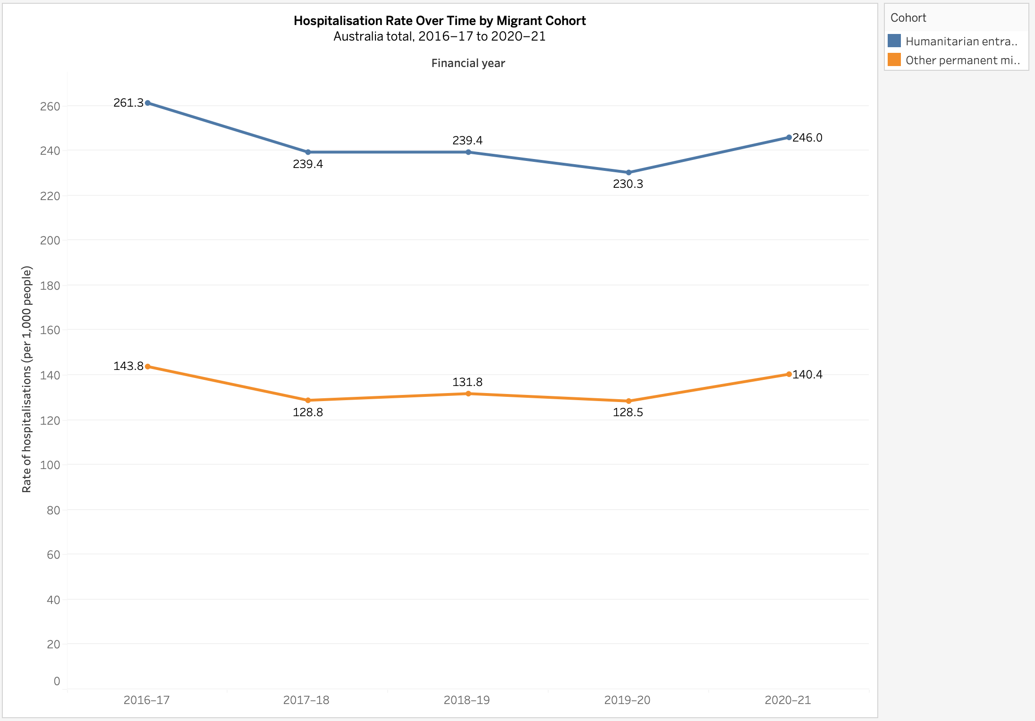
Hospitalisation Rate Over Time by Migrant Cohort Australia total, 2016-17 to 2020-21
The second visual compares the national hospitalisation rates for the two migrant cohorts over the five years using a line chart. Consistent higher rates were recorded for Humanitarian entrants. However, it decreased in 2019-20 by 31.3 (230.3 per 1000), followed by an increase in 2020-21 (246.0 per 1000). Largely similar pattern was followed by other permanent migrants, decreasing from 143.8 to 128.5, before increasing to 140.4 in 2020–21.
AIHW’s concludes that during the 2016-17 to 2020-21 period higher hospital and ED utilisation was noticed for humanitarian entrants that other permanent migrants (AIHW 2024).
The line charts impactfully displays periodic change because the values are placed on a common axis and connections between observations highlights direction. However, geographical variations are suppressed by national aggregation. Additionally historical trajectory and causal connections should not be drawn using the five observations, as they only describe the supplied period.

3.3 Lower-Urgency Emergency Department Presentations
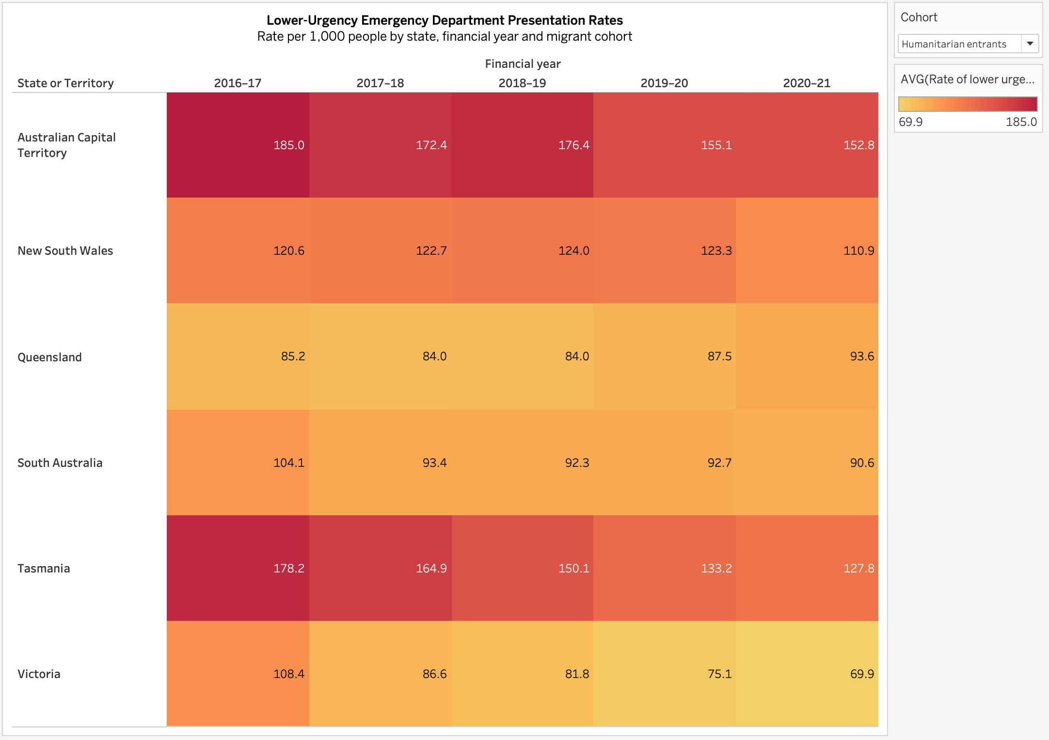
Lower-Urgency Emergency Department Presentation Rates Rate per 1000 people by state, financial year and migrant cohort
The consolidation of state, financial year and cohort was done using a heatmap, where lower-urgency ED is highlighted by the colour intensity, while the numerical labels offer precise value.
The humanitarian entrants decrease from 185.0 per 1,000 in 2016–17 to 152.8 in 2020–21 for Australian Capital Territory, Tasmania from 178.2 to 127.8 and Victoria from 108.4 to 69.9. Whereas Queensland increased from 85.2 to 93.6. The diverging trajectories highlights the value of geography and time together rather than showing a national average.
The colour coded rectangular cells in the heatmap reveal the structure in matrix-based data resulting compact and effective examining of multiple states across multiple years. The only limitation here is the colour differences are not interpreted as accurately as the differences in positions. However, numerical labels were used to overcome this limitation (Wilkinson and Friendly 2009)

3.4 Mode of Arrival at Emergency Departments
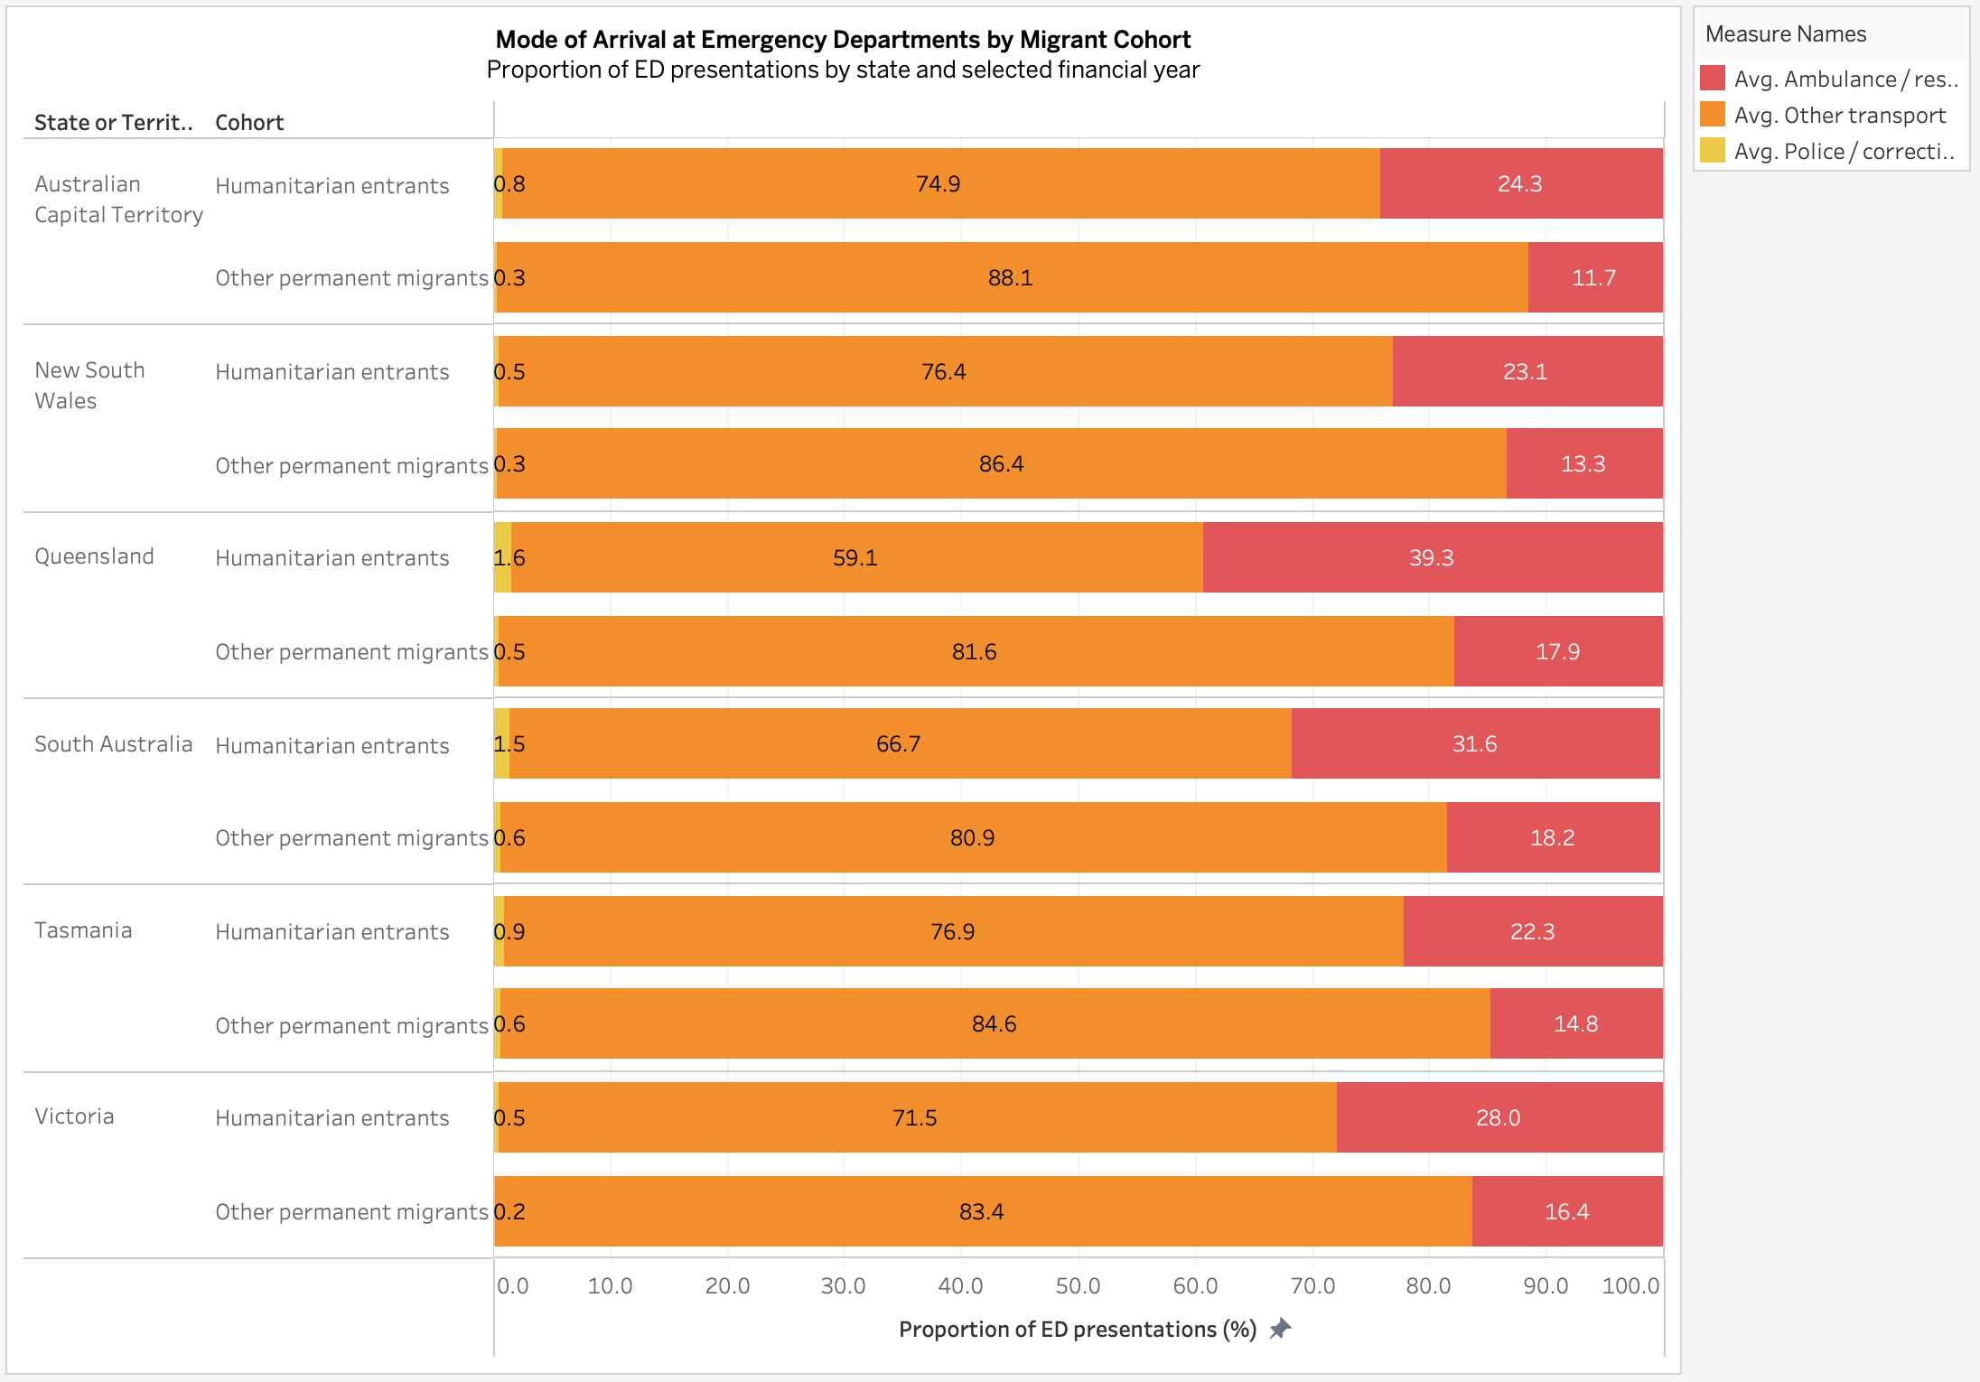
Mode of Arrival at Emergency Departments by Migrant Cohort Proportion of ED presentations by state and selected financial year
The ED arrival modes were compared using an 100% stacked horizontal bar chart, where each bar represents the segments of the ED presentations, divided into three categories ambulance or rescue, police or correctional transport, and other transport.
Year 2020-21 represents a clear cohort difference with Queensland, ambulance or rescue records for a 39.3% of humanitarian-entrant compared with 17.9% for other permanent migrants of ED presentations. Other states recorded a similar pattern of differences: South Australia (31.6% versus 18.2%), Tasmania (22.3% versus 14.8), Victoria (28% versus 16.4%), Australian Capital Territory (24.3% versus 11.7%) and New South Wales (23.1% versus 13.3%). AIHW reported ~28.5% of humanitarian entrants arrived by ambulance in 2020-21 versus 15.6% of other permanent migrants (AIHW 2024).
The 100% stacked bar clearly comminates composition. However, the internal segments do not necessarily start from a common baseline, resulting in difficulty for accurate comparison. To overcome this numeric label and tooltips are used for visual encoding.

3.5 Potentially Preventable Hospitalisations
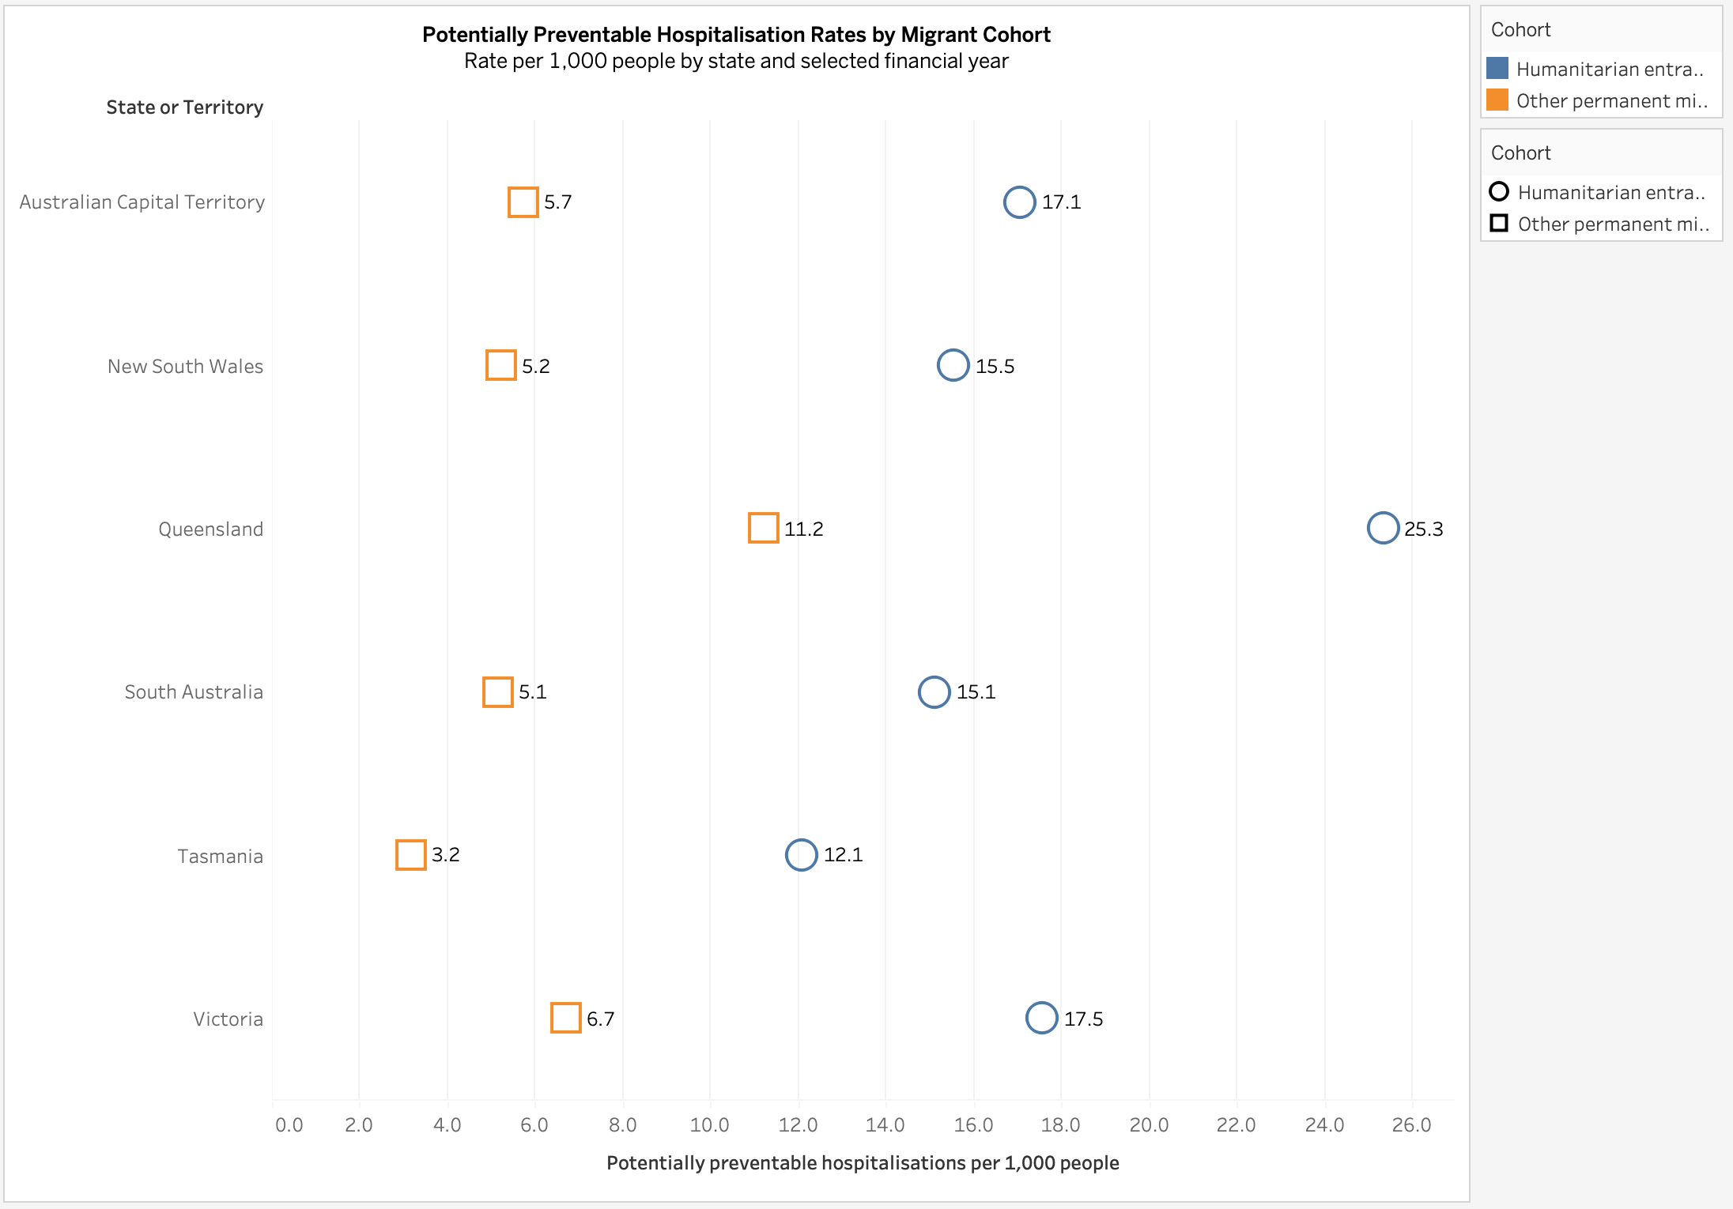
Potentially Preventable Hospitalisation Rates by Migrant Cohort Rates per 1000 people by state and selected financial year
For comparing the hospitalisation rates between cohorts, a dot plot with shared horizontal scale is very useful. In every jurisdiction in 2020-21 the humanitarian entrants recorded a higher rate with Queensland at 25.3 per 1000 for humanitarian entrants versus 11.2 for other permanent migrants resulting the largest among other states. Victoria at 17.5 versus 6.7, Australian Capital Territory 17.1 versus 5.7, New South Wales 15.5 versus 5.3, south Australia 15.1 versus 5.1 and Tasmania 12.1 versus 3.2.
The comparison between the gap and cohorts becomes easier with the position of each mark on the common scale, following a graphical perception principle (Cleveland & McGill 1984). Shapes and colours provide additional identification between the two categories.
The difference should not be entirely established as evidence for the potential cause for hospitalisation. However, language, health literacy and cultural expectations can be the cause for refugee health-service utilisation (Parajuli & Horey 2020; Robertshaw, Dhesi & Jones 2017).

3.6 Injury Hospitalisation Composition
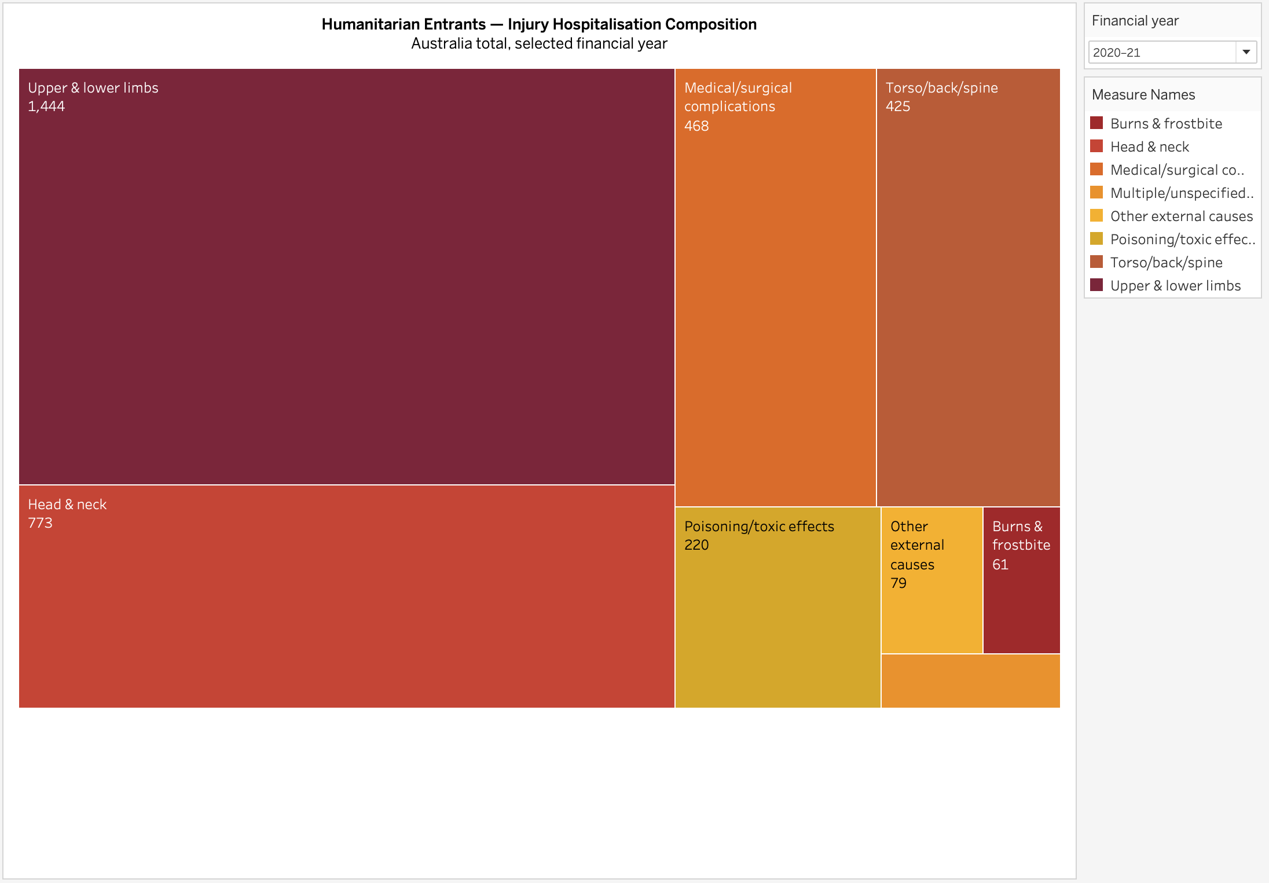
Humanitarian Entrants – Injury Hospitalisation Composition Australia total, selected financial year
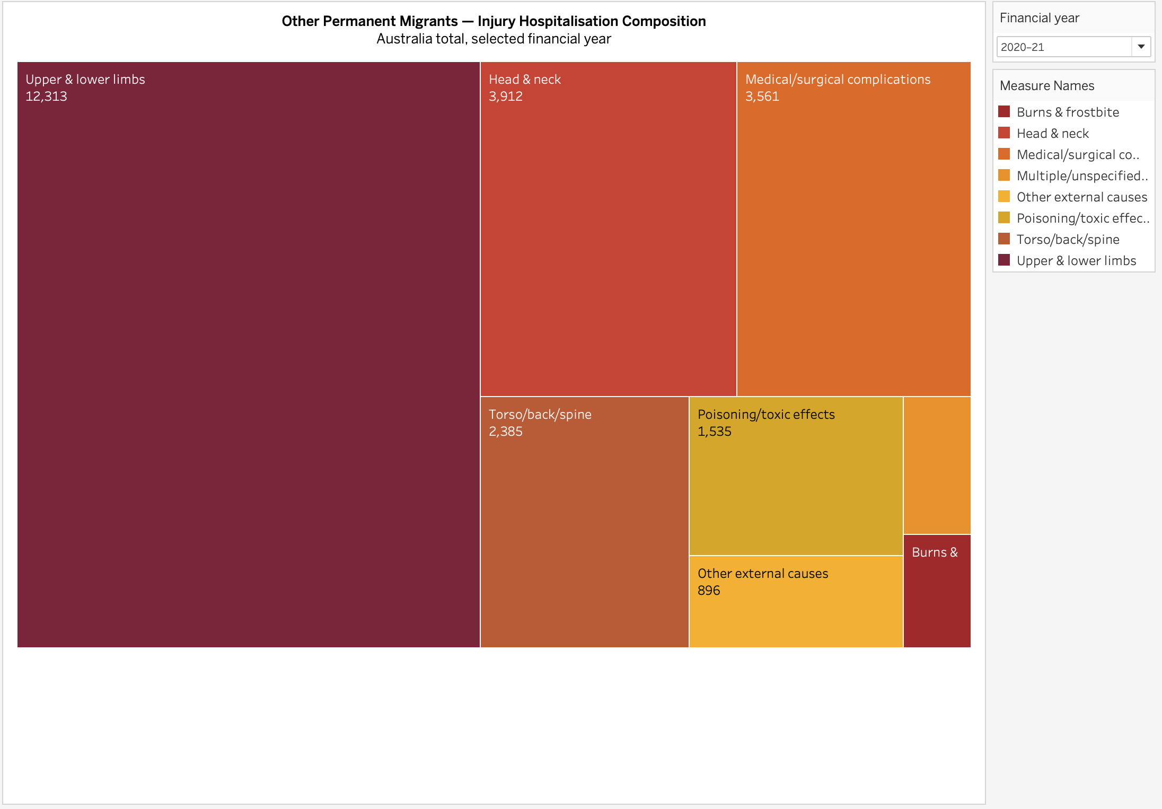
Other Permanent Migrants – Injury Hospitalisation Composition Australia total, selected financial year

The injury hospitalisation for two cohort humanitarian entrants and other permanent migrants is displayed in 2 separate treemaps. The humanitarian entrants recorded 3521 injury hospitalisations in 2020-21, evaluated against 25377 other permanent migrants. With humanitarian entrants at 1444 and other permanent migrants at 12313 records the highest for upper and lower limb injuries compared to all the other categories. Head and neck injuries at 773 versus 3912 and medical or surgical complications at 468 versus 3561. The injuries to the limbs are identified as an important category by AIHW in its hospital data (AIHW 2024).
The 2D space-filling treemaps with rectangle areas display the quantitative attributes (Shneiderman 1992). The proportional composition successfully communicates the less suitable conditions for accurate comparison (Cleveland & McGill 1984).

4. Dashboard Interaction, Large Data and Critical Evaluation
An interactive dashboard is built by integrating all six visuals, titled Healthcare Utilisation and Outcomes by Migrant Cohort in Australia. The dashboard shows a sequential storyline with first establishing spatial variation through geographical map, historical context through line chart, ED utilisation through heatmap and stacked bar chart, finally examine the injury composition and preventable hospitalisation.
The user can use the interactive filters for altering a specific migrant cohort or financial year. Tooltips are used for displaying the details without overlapping the information. To analyse multidimensional data fundamental interactive filters are very helpful as it allows analyst to toggle between the details for making accurate analysis (Heer and Shneiderman 2012).
The effectiveness of these techniques can be decreased if there are multiple geographical areas and extended time-period were added. The combination of visual exploration with data mining can benefit the analysis using huge datasets (Keim 2002).
The variables such as age, sex, population structure remains descriptive and uncontrollable for the analysis. As a result, continued examining of the dashboard is more important than to be treated as a normal model.

5. Conclusion
The overall analysis highlights the values of a multidimensional dataset for healthcare utilisation among humanitarian entrants and other permanent migrants. A higher hospitalisation rate was experienced by humanitarian entrants across the five-year period, with limited variation between the states. Geographical trajectories and humanitarian entrants with higher ambulance arrival rate among all the states was identified under lower-urgency ED. Humanitarian entrants also represented a higher rate for potentially preventable hospitalisation in 2020-21.
The geographic, temporal, matrix compositional and comparative techniques were used to provide complementary perspective as no single visualisation method could suffice the requirement. With specific cohorts and time-period the interactive Tableau dashboard clearly uses the multidimensional dataset to narrate the analysis in a clear and structured way. Even though, all the findings are not covered in this analysis the identified pattern can clearly guide the statistical and healthcare research.

Reference List
Australian Institute of Health and Welfare (AIHW) 2024, ‘Use of hospitals and homelessness services by refugees and humanitarian entrants’, Australian Institute of Health and Welfare, 26 July, viewed 29 August 2026, AIHW report.
Cleveland, WS & McGill, R 1984, ‘Graphical perception: theory, experimentation, and application to the development of graphical methods’, Journal of the American Statistical Association, vol. 79, no. 387, pp. 531–554, viewed 29 August 2026, DOI record.
Heer, J & Shneiderman, B 2012, ‘Interactive dynamics for visual analysis’, Communications of the ACM, vol. 55, no. 4, pp. 45–54, viewed 29 August 2026, University of Washington publication record.
Keim, DA 2002, ‘Information visualization and visual data mining’, IEEE Transactions on Visualization and Computer Graphics, vol. 8, no. 1, pp. 1–8, viewed 29 August 2026, Publication record.
Parajuli, J & Horey, D 2020, ‘Barriers to and facilitators of health services utilisation by refugees in resettlement countries: an overview of systematic reviews’, Australian Health Review, vol. 44, no. 1, pp. 132–142, viewed 29 August 2026, PubMed record.
Robertshaw, L, Dhesi, S & Jones, LL 2017, ‘Challenges and facilitators for health professionals providing primary healthcare for refugees and asylum seekers in high-income countries: a systematic review and thematic synthesis of qualitative research’, BMJ Open, vol. 7, e015981, viewed 29 August 2026, BMJ Open article.
Roth, RE 2013, ‘Interactive maps: what we know and what we need to know’, Journal of Spatial Information Science, no. 6, pp. 59–115, viewed 29 August 2026, Journal article.
Shneiderman, B 1992, ‘Tree visualization with tree-maps: 2-d space-filling approach’, ACM Transactions on Graphics, vol. 11, no. 1, pp. 92–99, viewed 29 August 2026, Publication record.
Wilkinson, L & Friendly, M 2009, ‘The history of the cluster heat map’, The American Statistician, vol. 63, no. 2, pp. 179–184, viewed 29 August 2026, Journal article.

